How to Use Rename Program

1. After Scanning Files:
   1. After scanning files to Cypress copy the files that were scanned and you wish to rename into the “TO RENAME” Folder on the desktop.

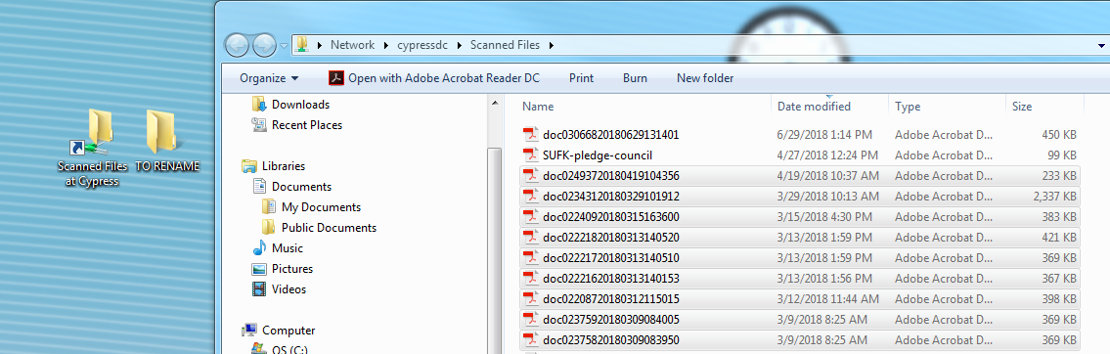

1. Opening Program:
   1. In the F: Drive you will find the “Rename Program”. Double click to open.

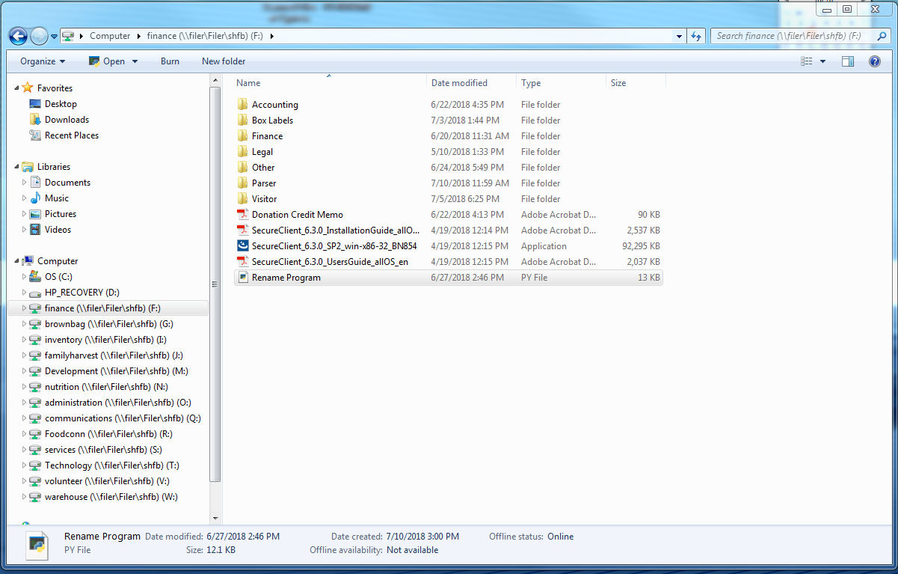

* 1. When The Program Opens Two windows will open.
     1. Terminal: This is where you will type input



* + 1. The File Rename Program:

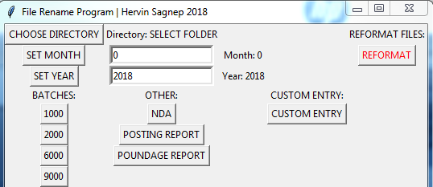

1. Choosing the Directory:
   1. Press the “CHOOSE DIRECTORY” Button, this will then prompt you to select the folder of the files to rename.

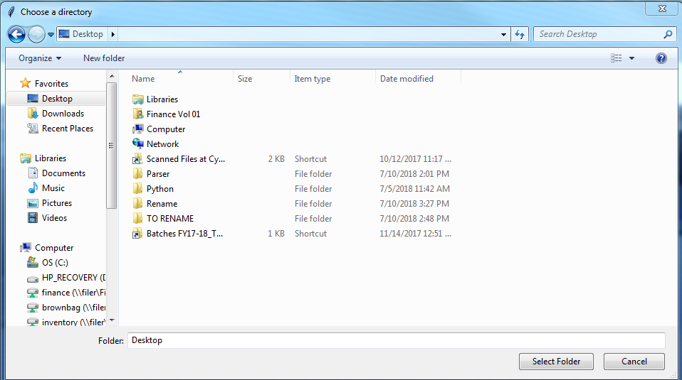

* 1. Set the folder to the folder called “TO RENAME”.

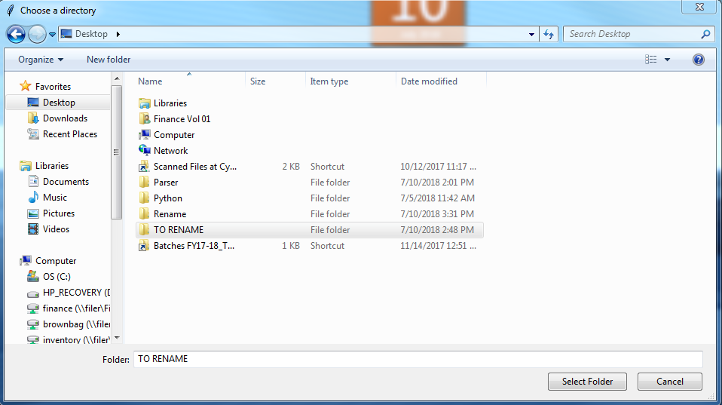

1. Setting Month and Year
   1. To set the Month, type the two digit representation of the Month then press “Set Month” Button.
   2. To set the Year, type the four digit representation of the Year the press “Set Year” Button
2. Renaming Batches and Other Files:
   1. After you have chosen the directory, set the month, and set the year press the Batch Type that you renaming.
3. Reformat Files:
   1. After you have renamed all the files in the folder, ensure that that there are no errors in the renaming, look for duplicates or missing digits.
   2. If there are errors you must manually rename the file:
   3. After checking that there are no errors press the “REFORMAT” button to remove the digits in front of the name files:
   4. Transfer to the proper FY and Batch Type